Radiation Therapy Physics I
Final Exam Fall 2017

Name: J.R. Powers-Luhn

Question #1: What are the tolerances for the following TG-142 tests for an IMRT machine?

TG-142 Test |  | Tolerance IMRT Machine
X-Ray and Electron Output Consistency (Daily) |  | 3%
Cone Beam CT - Imaging and Treatment Coincidence (Daily) |  | <2mm (non-SRS/SRBT)/<1mm (SRS/SRBT)
Gantry Angle (monthly) |  | 1º
Asymmetric Jaw Positioning (monthly) |  | 1mm
Planar MV EPID - Contrast (monthly) |  | Baseline
Localizing Lasers (monthly) |  | ±1mm
X-ray Flatness change from baseline (Annual) |  | 1%
Output Factors for Electrons (Annual) |  | 1%

Question #2: In multileaf collimators with rounded MLC leaf tips, why does one have to measure the effective leaf tip shift? Describe a method for measuring the effective leaf tip shift.

The concern with effective leaf tip shift is that the tips of the leaves are thinner than the body of the leaf. The dose error for small gaps is therefore much larger for smaller nominal leaf gaps. In order to correct for this, the effective leaf shift must be measured.

The leaf tip shift can be measured by using multiple static MLC fields. First one leaf is positioned beyond the desired position (by ½ the estimated gap) and an exposure is made. Then it is restored and the opposing leaf is placed beyond the desired position by ½ the estimated gap and an exposure is made. The double exposure is then used to measure the gap.

Question #3: Describe the correction factors that are required for using radiochromic film for IMRT patient specific quality assurance.

- The film acts differently based on being face-up or face-down; it must be placed such that the polyester base (smooth side) is facing the glass window and the manufacturer’s slit marking is in the top right corner
- When scanning the film, the film must always be placed in the same position as the scanner does not respond uniformly over its entire scan field. A template is used to ensure that the film is placed in the center of the scanner with the short dimension of the film parallel to the long dimension of the scanner.
- During scanning, the film can flex, producing “contrast bands”. These can be corrected by placing the film in a clear plastic sleeve which maintains the film in a single plane in front of the slit.
- When scanning the film, the readout has a temperature dependence. In order to control/correct for this, the scanner should be turned on for 30 minutes before measurements and five preview scans (with no film) should be performed to warm up the scanner lamp. This helps to ensure that the temperature in the scanner is the same as when the calibration curve was generated. The scanner should not be used for too many consecutive scans, as this could increase the temperature.
- The film’s optical density continues to develop following exposure. In order to correct for this when measuring absolute doses, wait for two hours (EBT2 film) or six hours (EBT film) to allow for image stabilization prior to scanning.
- The film must be background corrected prior to interpretation. This can be done by scanning the film prior to irradiation and subtracting this value from the scan of the exposed film, or by using the blue channel on exposed film as a baseline/background image.

Question #4: What are the advantages of using array detectors as compared to radiographic or radiochromic film?

Array detectors have the advantage of being able to provide a large number of dose measurements available immediately (without the need to develop a piece of film). They can also provide absolute dose verification once properly calibrated.

Radiographic film requires a wet processing capability which some facilities no longer have. Radiochromic film requires careful handling and cannot be scanned for 2-6 hours after exposure.

Question #5: Describe the process by which Optically Stimulated Luminescence (OSL) measure radiation dose. Include a diagram that shows the conduction band, gap, and valence band.

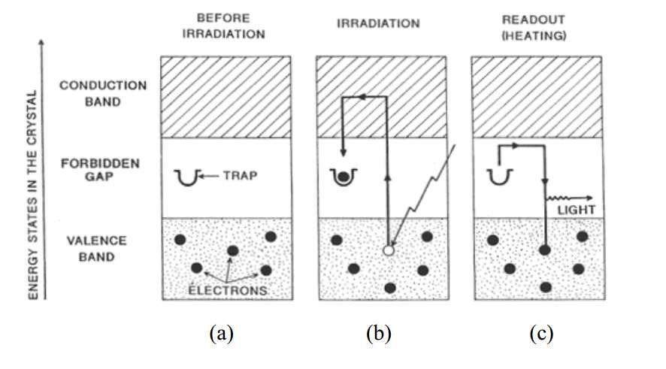 When an appropriate crystal (e.g. CaF, Al₂O₃) is exposed to radiation, some electrons in the valence band are excited into the energy gap between the valence and conduction band. The electron then stays in a metastable state in the gap region (since there is no high-probability transition back to the valence band). When the crystal is heated, the thermal excitation allows the electron to relax back into the valence band, emitting light. The amount of light emitted can be recorded and translated into the dose recorded by the dosimeter.

This means that the TLD can only be measured once.

Question #6: Describe the components of a High Dose Rate (HDR) remote afterloader including a discussion of Ir-192.

- Radioactive source: Ir-192, with a specific activity of 450 Ci/g and gamma energy of 380 keV. Typically these sources are 3-10 mm long and <1mm in diameter at the end of a steel cable. The source must be changed every 3 months due to Ir-192’s half life of only 74 days.
- Source drive mechanism: A stepper motor drives the cable with the source at the end. Two copies of this mechanism exist, one with a check cable and one with the source cable. The check cable/drive operates first to validate performance of the system before the source cable is deployed. The movement of the source is validated by the optical encoder.
- Indexer: The source cable can be directed into one of several catheters using connecting guides called “transfer tubes”.
- Treatment control: Transfers the data to the afterloader. Also provides the mechanism to stop treatment in the event of pressing the INTERRUPT button.
- Safety interlocks: several “emergency off” switches are located throughout the facility, at least on top of the treatment head and at the treatment control station. Door interlocks prevent treatment while the door is open, preventing irradiation of anyone besides the patient.
- Emergency crank: If the source cable fails to retract normally it can be removed using the manual crank (requires the operator to enter the treatment room with the source exposed).
- Backup battery: A backup battery exists to retract the source in the event of a loss of primary power.

